**Apsara Project Structure and Rule**

|  |  |  |  |
| --- | --- | --- | --- |
| **Version** | **Date** | **Description** | **Author** |
| V0.1 | 30-06-2020 | User guide | Hor Vitou |
|  |  |  |  |
|  |  |  |  |

* **Apsara Project Structure**

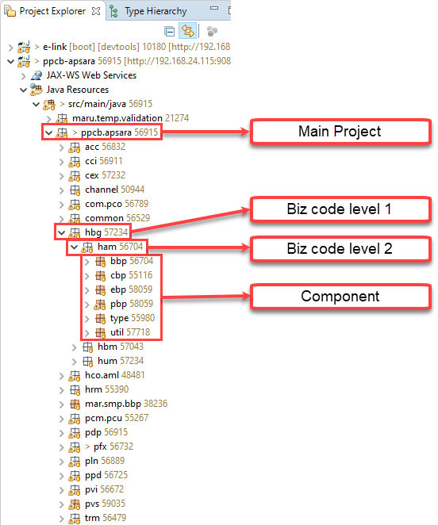

* **Component Naming Convention**
  + **pbp** (Process Business Package)
    - **pbc** (Process Business Component)

Example: **RetrieveCustomerDetailPbc.java**

* + **cbp** (Common Business Package)
    - **cbc** (Common Business Component)

Example: **RetrieveCustomerDetailCbc.java**

* + **ebp** (Entity Businesss Package)
    - **ebc** (Entry Business Component)

Example: **RetrieveCustomerDetailEbc.java**

* + **ccp** (Center Cut Package)
    - **ccc** (Center Cut Component)

Example**: RetrieveCustomerDetailCcc.java**

* + **dbp** (Deferred Business Package)
    - **dbc** (Deferred Business Component)

Example: **RetrieveCustomerDetailDbc.java**

* + **bbp** (Batch Business Package)
    - **bbc** (Batch Business Component)

Example: **RetrieveCustomerDetailBbc.java**

* **Class Naming**
  + “**Insert**” change to “**Register**”
  + “**Update**” change to “**Update**”
  + “**Delete**” change to “**Cancel**”
  + “**Get, Select**” change to “**Retrieve**”
  + “**Get List, Select List**” change to “**RetrieveList**”
* **Coding Rule**
  + **Pbc class** must be call “**BankPreProcessCbc**” and “**BankPostProcessCbc**”
  + **Pbc class** can call **Ebc class, Cbc class**
  + **Pbc class** must be add annotation **@PBC**
  + Method **Pbc class** must be add annotation **@Operation**

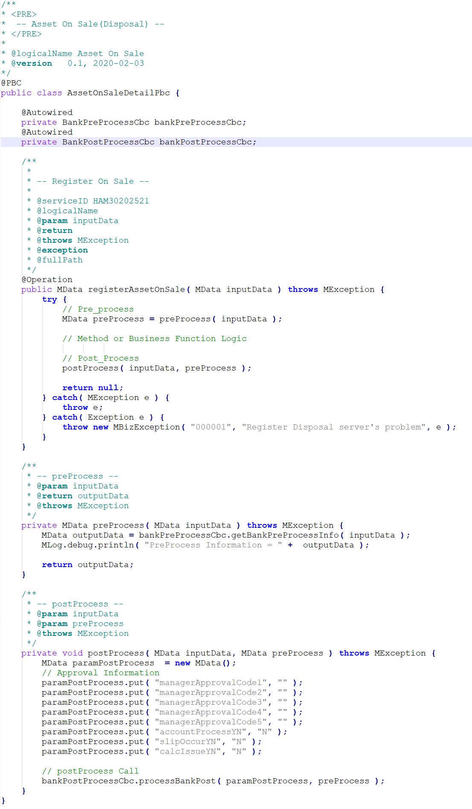

* + **Cbc class** can call **Ebc class and Cbc Class**
  + **Cbc class** must be add annotation **@CBC**
  + Method **Cbc class** must be add annotation **@Operation**
  + Use **Cbc** when need to share method to other people to use and in class need to use with **Ebc**

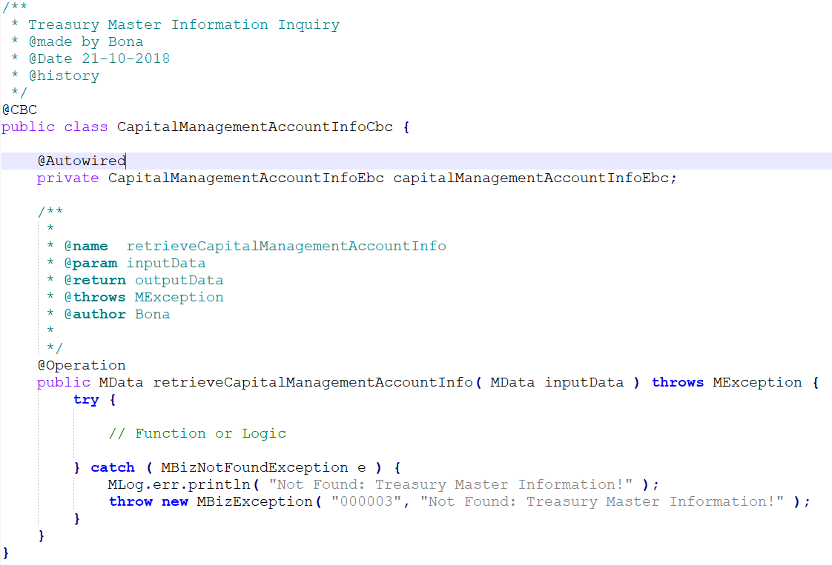

* + **Ebc class**  and **XML file** must be have the same name
  + **Ebc class** must be add annotation **@EBC**
  + Method **Ebc class** must be add annotation **@Operation**
  + Must be extend **MDaoEbcSupport** **class**

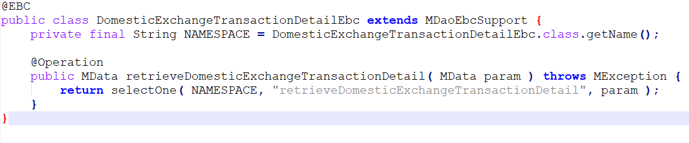

* **XML Source**
  + File xml name must be the same with Ebc class
  + Structure folder xml must be have biz level 1 and biz level 2 and xml file

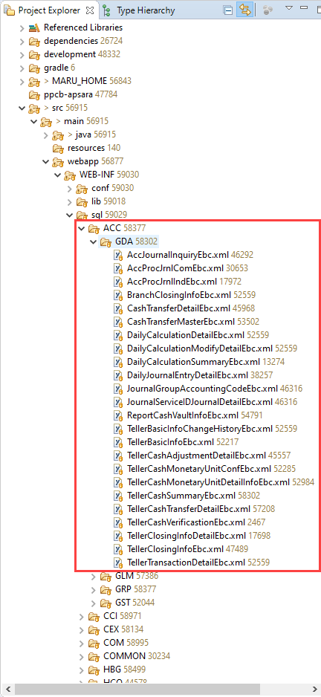

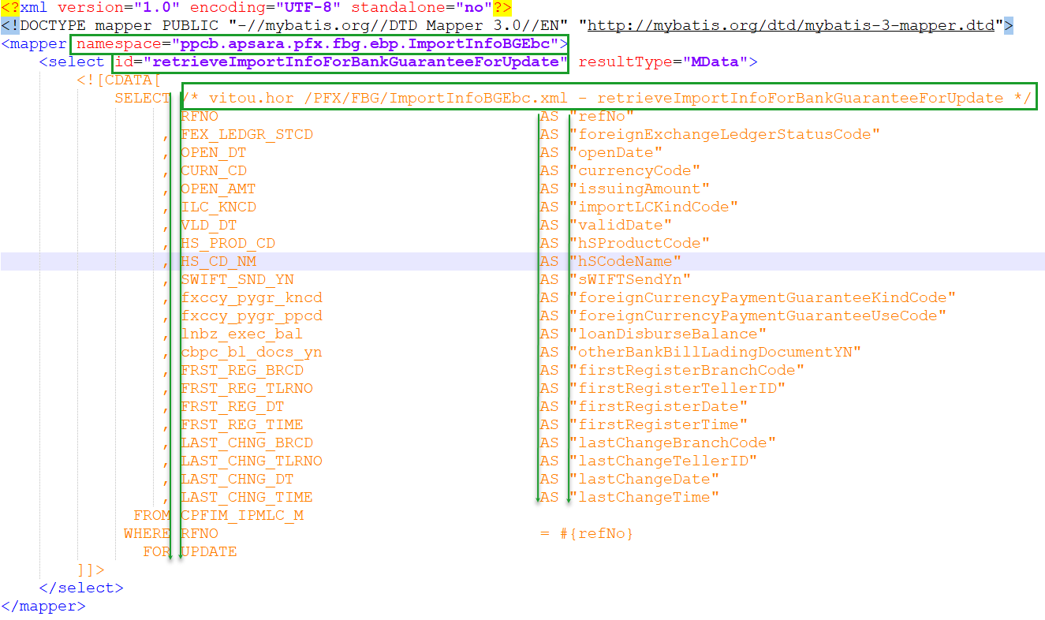

**Check user guide SQL “PPCBanking_SQL_Writing_GUIDE_v1.1.pptx” for more detail.**

* **Core Banking Data**
  + In Core Banking data when insert into table must be double check the data correct follow column table and format accountNo, customerNo, datetime,….are must be correct format
  + **AccountNo** in table must be have **16 digit**. Eg: **0001120000086644**
  + When display in screen or UI must be have **13 digit**. Eg: **1-120-00008664-4**
  + **CustomerNo** in table must be have **16 digit**. Eg: **0000000000215655**
  + When display in screen or UI must be have **11 digit**. Eg**: 00-00021565-5**
  + **Date** in table must be have format **YYYYMMDD**
  + When display in screen or UI must be have format **DD-MM-YYYY**